

Agency Long Descriptions

American Red Cross – Central Midwest Georgia
706-884-5818

Holly Long, Executive Director
holly.long2@redcross.org
900 Dallis Street, Suite C, LaGrange, GA 30240
The American Red Cross prevents and alleviates human suffering in the face of emergencies by mobilizing the power of volunteers and the generosity of donors. The American Red Cross aspires to turn compassion into action so that all people affected by disasters receive care, shelter and hope; our communities are ready and prepared for disasters; everyone has access to safe, lifesaving blood and blood products; all members of our armed services and their families find support and comfort whenever needed; and in an emergency, there are always trained individuals nearby, ready to use their Red Cross skills to save lives. Specific services include 24 hour a day disaster assistance; 24 hour a day communication links for military members and their families with emergency situations; CPR, First Aid and Water Safety training; readiness and preparedness training; and blood donation support on the local level.

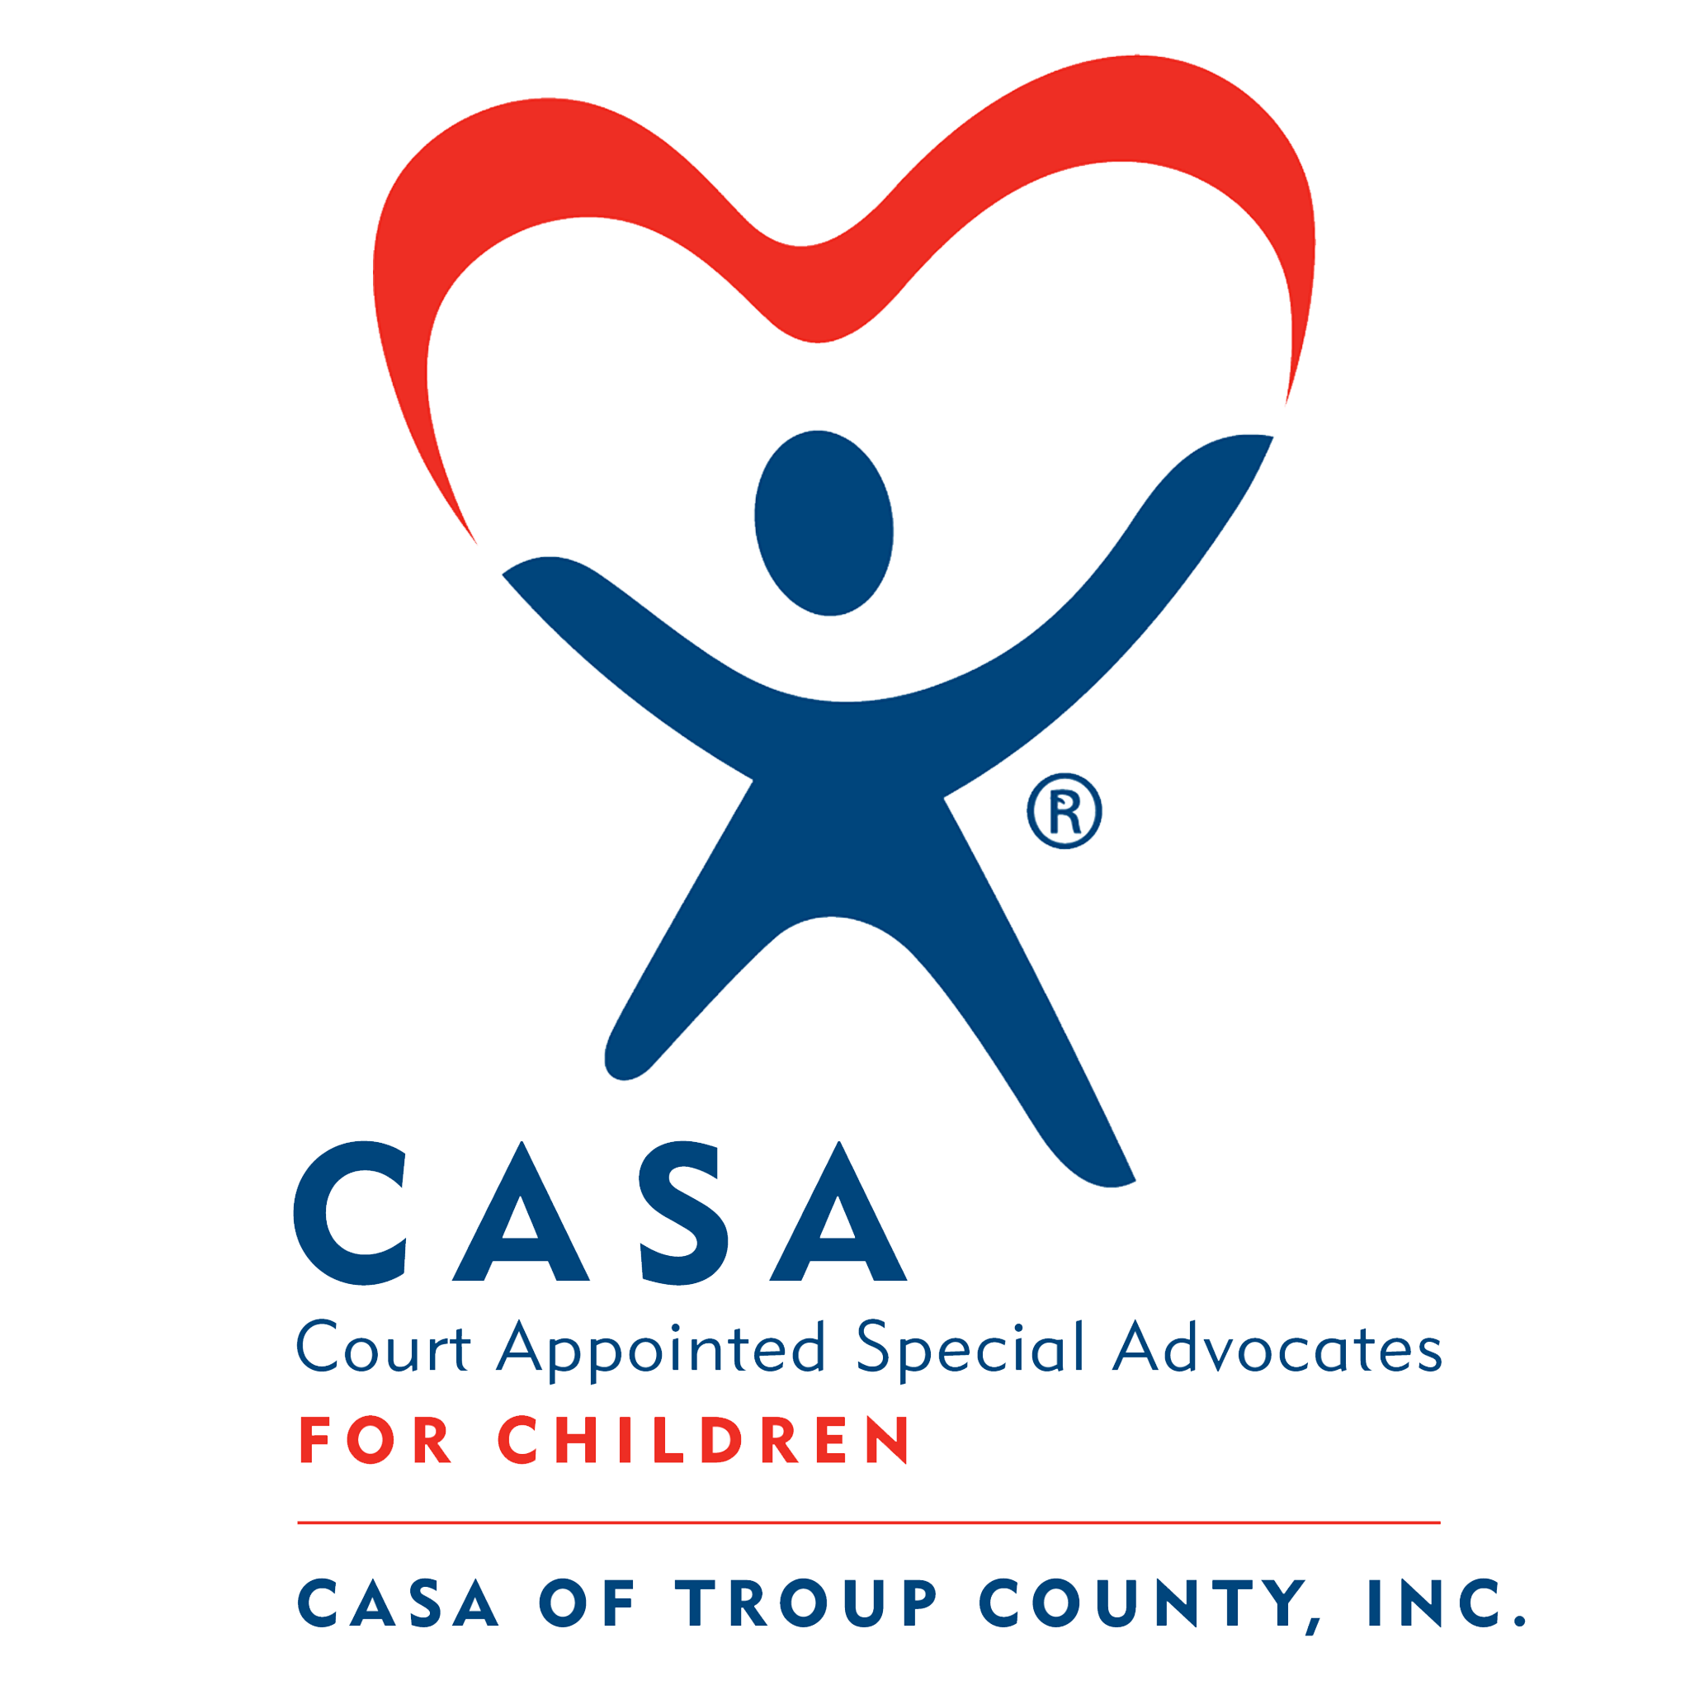

CASA of Troup County, Inc.

706-845-8243

Shannon Lawson, Executive Director
slawson@casaoftroupcounty.org
100 Smith Street, Suite 4, LaGrange, 30240

(Court Appointed Special Advocate) Mission is to give children a voice in court. It is to advocate for the best interest of abused and neglected children involved in juvenile deprivation proceedings. CASA of Troup County provides screened, trained, and supervised volunteers who speak for the needs of these children, one child at a time.



Children’s Advocacy Center of Troup County
706-298-0050 x1064
Kim Adams, Executive Director
kadams@twincedars.org
PO Box 1526, LaGrange, GA 30241
Serves as the central hub for a coordinated systems and family-centered practice approach to child abuse investigations which involve allegations of sexual, physical or extreme emotional abuse as well as investigations involving children who have been commercially and sexually exploited as well as children that have been witness to a violent crime. Conducts legally sound, forensic interviews and sexual assault exams for all arms of law enforcement and Child Protective Services (DFCS) as well as follow-up, trauma-focused victim support services for victims and/or non-offending caregivers. Provides administrative duties as well as oversight of the county-wide Child Abuse Protocol and Child Fatality Review for the Office of the District Attorney’s Office.



Circles of Troup County
706-883-1687
Sherri Brown, Director
sbrown@troupcountyga.gov
1220 Lafayette Parkway, LaGrange, GA 30241

Circles of Troup County works to identify and eliminate the causes of poverty and support those wishing to lift themselves out of poverty. Circles uses a relational strategy to support both parents and children moving out of poverty while inspiring and equipping the community to reduce its poverty rate.



Communities In Schools
706-298-7121
Tabitha Coverson, Director
tcoverson@cisgeorgia.org
1220 Hogansville Road, LaGrange, GA 30241
Promotes Life success by working with youth most susceptible to school dropout; within the school setting, program addresses critical issues such as school academic, attendance, literacy, job preparedness, teen pregnancy, drug and alcohol prevention, low self-esteem, disruptive and violent behavior. Volunteers support CIS program by serving as mentors and tutors. This special connection allows students to experience a meaningful, one-on-one relationship with a caring adult.


Foster Grandparents Program
706-298-3612
LaShonda Smith, Program Manager
lashonda.smith@dph.ga.gov
900 Dallis Street, LaGrange, GA 30240
The Foster Grandparents Program provides a way for volunteers age 55 and over to share love, time, and experience, which empowers them to help a child in need. Foster Grandparent volunteers serve up to 40 hours per week as a role model, a mentor, and a friend. Serving at one of many local organizations—including faith-based groups, Head Start Centers, schools, and other youth facilities—they help children learn to read, provide one-on-one tutoring, and guide children at a critical time in their lives. Put simply, they give the kind of comfort and love that sets a child on the path toward a successful future.



Harmony House (Domestic Violence Shelter)
706-885-1525
Michele Bedingfield, Director
MLB@harmonyhousega.org
PO Box 2925, LaGrange, GA 30241
Harmony House provides shelter, security, crisis intervention, education, and advocacy for adults and children who are victims of domestic violence and has a 24-hour-a-day crisis line.
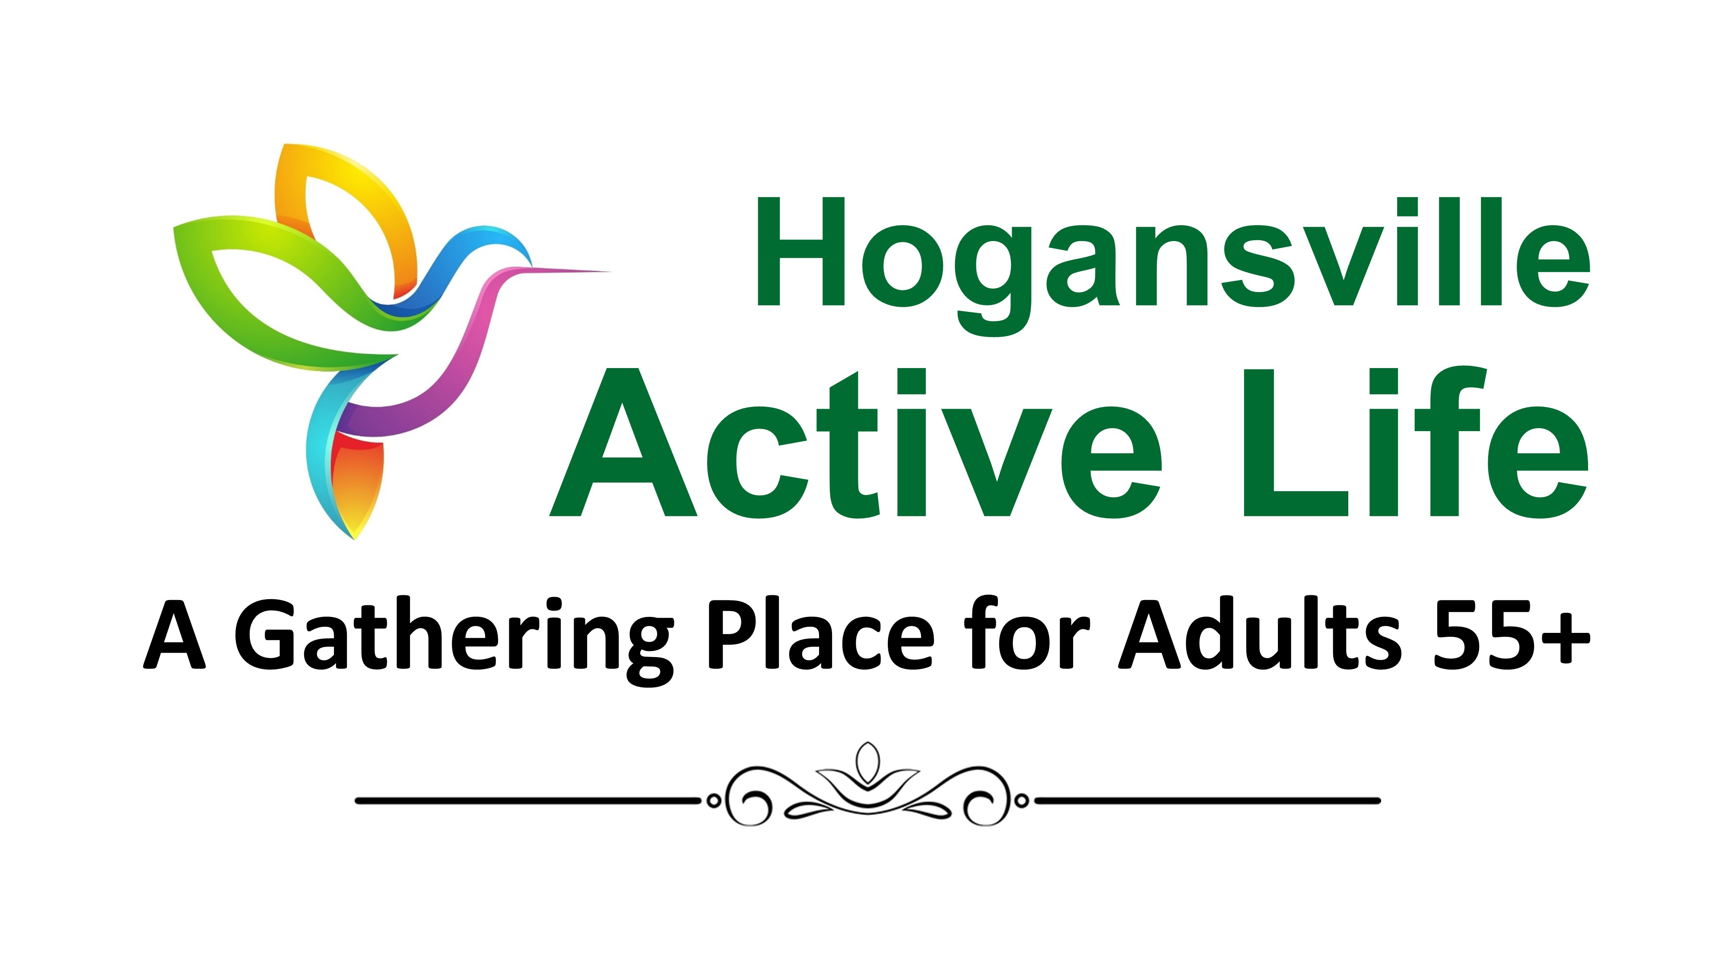

Hogansville Active Life
706-637-6606
Renay Fannin, Site Manager
rfannin@theactivelife.org
407 Church Street, Hogansville, GA 30230
The Active Life Center in Hogansville provides programs of interest and other activities to seniors 55 and older to form friendships and provide companionship with others. Services include transportation, information and referral, and a nutrition program which provides hot, well-balanced meals to those at the Center as well as delivering to many that are home bound. Special events, field trips, health and recreational activities are also offered.


Hogansville Empty Stocking Fund
706-880-5362
Janie Dollar
janie.dollar@gmail.com
Administered by the Hogansville Pilot Club, Donna Arnold, President
P.O. Box 85, Hogansville, GA 30230
Sponsored by the Hogansville Pilot Club, this project buys toys and clothes for needy children in the Hogansville area at Christmas.



LaGrange Active Life
706-883-1681
Jessica Maddox, Site Manager

jmaddox@theactivelife.org

140 Ragland Street, LaGrange, 30241
Activity center for independent older adults (55+). Including exercise, art & crafts, recreation, games, computer training, singing, dancing, travel, and fellowship with other older adults. Provides weekly presentations on health, nutrition, and other topics of interest to older adults. Transportation services available. Lunch served at the center as well as a meal delivery for home bound.


LaGrange Personal Aid Association, Inc. Programs:
706-882-9291
Paul Stedman, Executive Director
lagpersonalaid@gmail.com
300 Bull Street, LaGrange, GA 30240
- LaGrange Empty Stocking Fund
Provides Christmas gifts for needy and low-income children ages 0-8.
Administered by LaGrange Personal Aid.
- LaGrange Personal Aid
Emergency assistance agency. Aids during times of distress, illness, misfortune or emergency. Supports the family through rental, mortgage, and utility payments when the major income earner is ill or hospitalized and is out of work under a doctor’s care. Utility assistance provided through the SHARE and Round-Up programs with funds provided by customers of the City of LaGrange and Diverse Power. Additional programs include Charles C. Maddox Veterans Assistance Program, prescription purchases, medical & emergency transportation assistance, transient aid, medical supplies payment assistance, Ensure and juice for the elderly, summer fan and air conditioner program, school supplies and Senior Christmas program. Screening services provided for the Lions Club Glasses Program, Troup Cares Free Medical
Clinic, West Georgia Physicians, Goodwill Voucher Program. Co-Administrator of the local CharityTracker Online Database. Established January 1923.

- Interfaith Food Closet
Coordinator, Jennifer Tenney
Provides temporary and emergency food assistance. Also provides personal care items when available. Established April 1983. Administered by LaGrange Personal Aid.

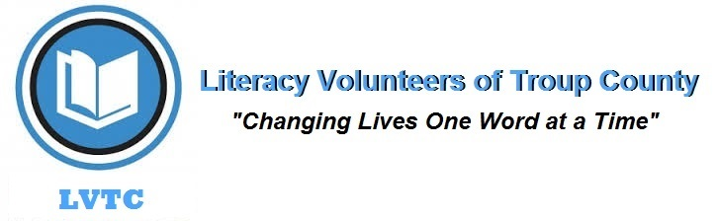

Literacy Volunteers Troup County, Inc.
706-883-7837
Jan Plagens, Coordinator
literacyvolunteerstc@gmail.com
PO Box 1087
200 Main Street Suite 201, LaGrange, GA 30241
Provides reading and writing instruction for non-literate adults on a one-on-one basis. Trains volunteers to be reading and writing tutors. Affiliate of Pro Literacy.



Maidee Smith Early Care and Learning Center
706-884-3788
Maxine Maddox, Director
msmdcc@bellsouth.net
607 Union Street, LaGrange, GA 30240
Licensed and quality rated day care center for children six weeks to five years of age, staffed with qualified teachers providing day care with the benefit of planned activities and essential learning skills in a loving environment. Offers quality, low-cost care to children whose parents work and is in operation five days per week from 6:30 a.m. to 5:00 p.m.


Salvation Army
706-884-6842
William Atkins, Director
william.atkins@uss.salvationarmy.org
PO Box 3087
202 Church Street, LaGrange, GA 30241
On a day-to-day basis the organization provides families in crisis situations, assistance in the forms of clothing, food, furniture, medical prescriptions, rent, and utilities. During the summer, the organization provides a weeklong camping experience in the north Georgia Mountains to underprivileged youth. At Christmas the Organization provides new clothing, new toys and wholesome food boxes to low-income families who otherwise could not afford these items for Christmas. All requests for assistance are evaluated through a formal interview process.
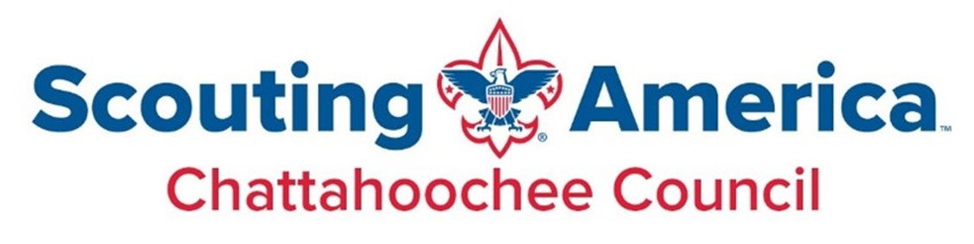

Scouting America (Boy Scouts of America)
Chattahoochee Council Yellow Jackets District

706-327-2634 706-327-2634
Tonya Dobbins, Scout Executive Scott Rehrauer
Tonya.dobbins@scouting.org Scott.Rehrauer@scouting.org
1237 1st Ave. Columbus, GA 31901 PO Box 2126, LaGrange, GA 30241
Offers various programs for young people that encourage character building, good ethical decision making, and personal and mental fitness. Cub Scouting is for ages 7-11. Boy Scouting is for boys ages 11-17. Exploring is for both young men and women ages 14-20. Throughout the year, special events for each of these programs are put on locally including Camp Cow Pie, Boy Scout Summer Camp, and Explorer Ski Weekend.

Self Help Harbor, Inc.
706-884-6993
Diethard Lindner, Board Chair
4dlindner@gmail.com

909 Stonewall Street, LaGrange, GA 30240

The purpose of Self Help Harbor, Inc. is to provide a safe and easily accessible environment for twelve step recovery groups to meet. Self-Help Harbor, Inc. presently provides meeting rooms for Alcoholics Anonymous, Alanon, and Narcotics Anonymous. The Self Help Harbor is open 7 days a week including all holidays and provides services to approximately 200 people who attend one or more meetings monthly.


Senior Companions Program
706-298-3612
LaShonda Smith, Program Manager
lashonda.smith@dph.ga.gov
900 Dallis Street, LaGrange, GA 30240
The Senior Companions Program provides a way for volunteers age 55 and over to share their experiences and compassion. Senior Companions volunteers serve up to 40 hours per week helping adult clients 60 years and older live independently in their own homes. Whether the Senior Companions are giving families or professional caregivers much-needed time off, running errands, or simply being a friend, they make a difference that strengthens and helps preserve an individual’s independence.


Troup County Special Olympics
706-883-1670
J. J. Kuerzi, Facilities Manager, Special Olympics Program Coordinator
jj4utvols@yahoo.com or jjkuerzi@troupco.org
Troup County Parks and Recreation, 1220 Lafayette Parkway, LaGrange, GA 30241
Troup County Special Olympics empowers people with intellectual disabilities to realize their full potential and develop their skills through year-round sports training and competitions, giving them continuing opportunities to develop physical fitness, demonstrate courage, experience joy, and participate in a sharing of gifts, skills and friendship with their families, other Special Olympic athletes, and the community. Through sports training we work on health and fitness, personal hygiene, social appropriateness, money management, self-esteem, and respect for others and themselves. Along with sports training we work on money management, time management and what it means to be a team player and an active citizen in our community.



Success by 6
706-884-8292
Gail Gordon, Coordinator
ggordonsb6@gmail.com
PO Box 532
200 Main Street, LaGrange, GA 30241
Success By 6 is United Way’s early learning community impact initiative that helps prepare our youngest children for learning when they get to school. Local and state SB6s pursue multiple strategies – including public awareness, parent education, increasing quality childcare, and increasing access to services (like health care & literacy) – to galvanize communities to help young children come to school ready to succeed. SB6 is the nation’s largest network of early childhood coalitions.
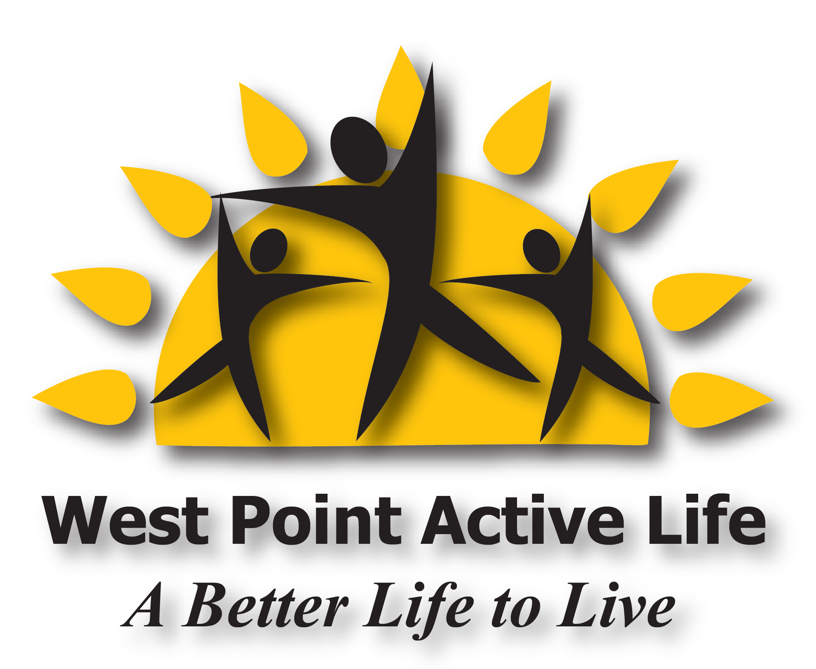

West Point Active Life
706-645-3580
Steve Davis, Site Manager
sdavis@theactivelife.org
1114 O. G. Skinner Drive, West Point, GA 31833
The West Point Active Life is an activity center for adults 55 and older. Its mission is to provide recreation for older adults that enhances quality of life, empowers independence, and extends lifespan in the West Point area.

